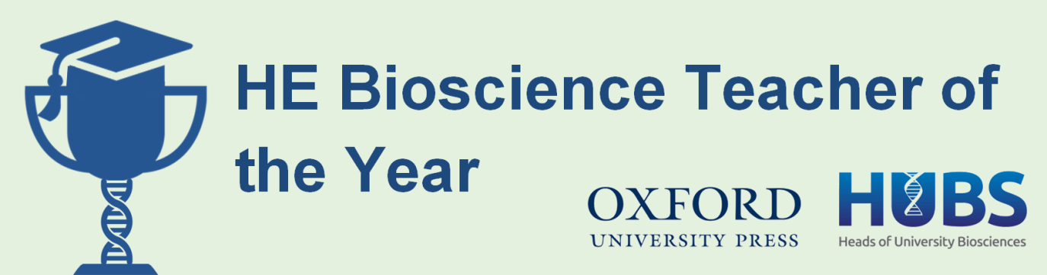

2019 Award: Student Suggestion Form

The Higher Education Bioscience Teacher of the Year Award seeks to identify the UK's leading bioscience teachers, and highlights the invaluable role they play in educating and inspiring the next generation of biologists. For full information, please visit the Royal Society of Biology website.

This form should only be completed by students wanting to suggest candidates for the Award. Completed forms should be sent to Eleanor Kirby-Green by Wednesday 3 October 2018. The Royal Society of Biology will then forward this information to the candidate and their senior management. It is then up to the suggested candidate to formally nominate themselves for the Award.

Note: If you are an academic wanting to nominate yourself or a colleague, please use our application form.

- Candidate details

Please supply the details of the candidate you wish to suggest for the Award.
First name |  | Surname
Other name |  | Title
Job title
Department or School
University
Work tel.
Email

- Why does your suggested candidate deserve the Award?

Please provide details of the candidate’s teaching methods and how these have enhanced your learning. It may help to consider the following questions:
- How did they help you to understand a biological concept?
- How do they keep you engaged during their lectures/practicals?
- How do they inspire you to learn more about your subject?
- How do they go the extra mile to support your learning?

- Your details

You are welcome to suggest candidates anonymously by leaving these fields blank. However, candidates are more likely to formally apply for the Award if you supply your details, and they can use it as evidence in their application.
First name |  | Surname
Course |  | Year
Email
Your units/modules taught by the candidate

- Finally, please tell us how you heard about the HE Bioscience Teacher of the Year Award:

Please submit all completed forms to Eleanor Kirby-Green by 3 October 2018

The deadline for candidates to formally apply for the Award is Wednesday 24 October 2018. Therefore, the sooner you submit your suggestion, the more time your candidate has to apply for the Award!

